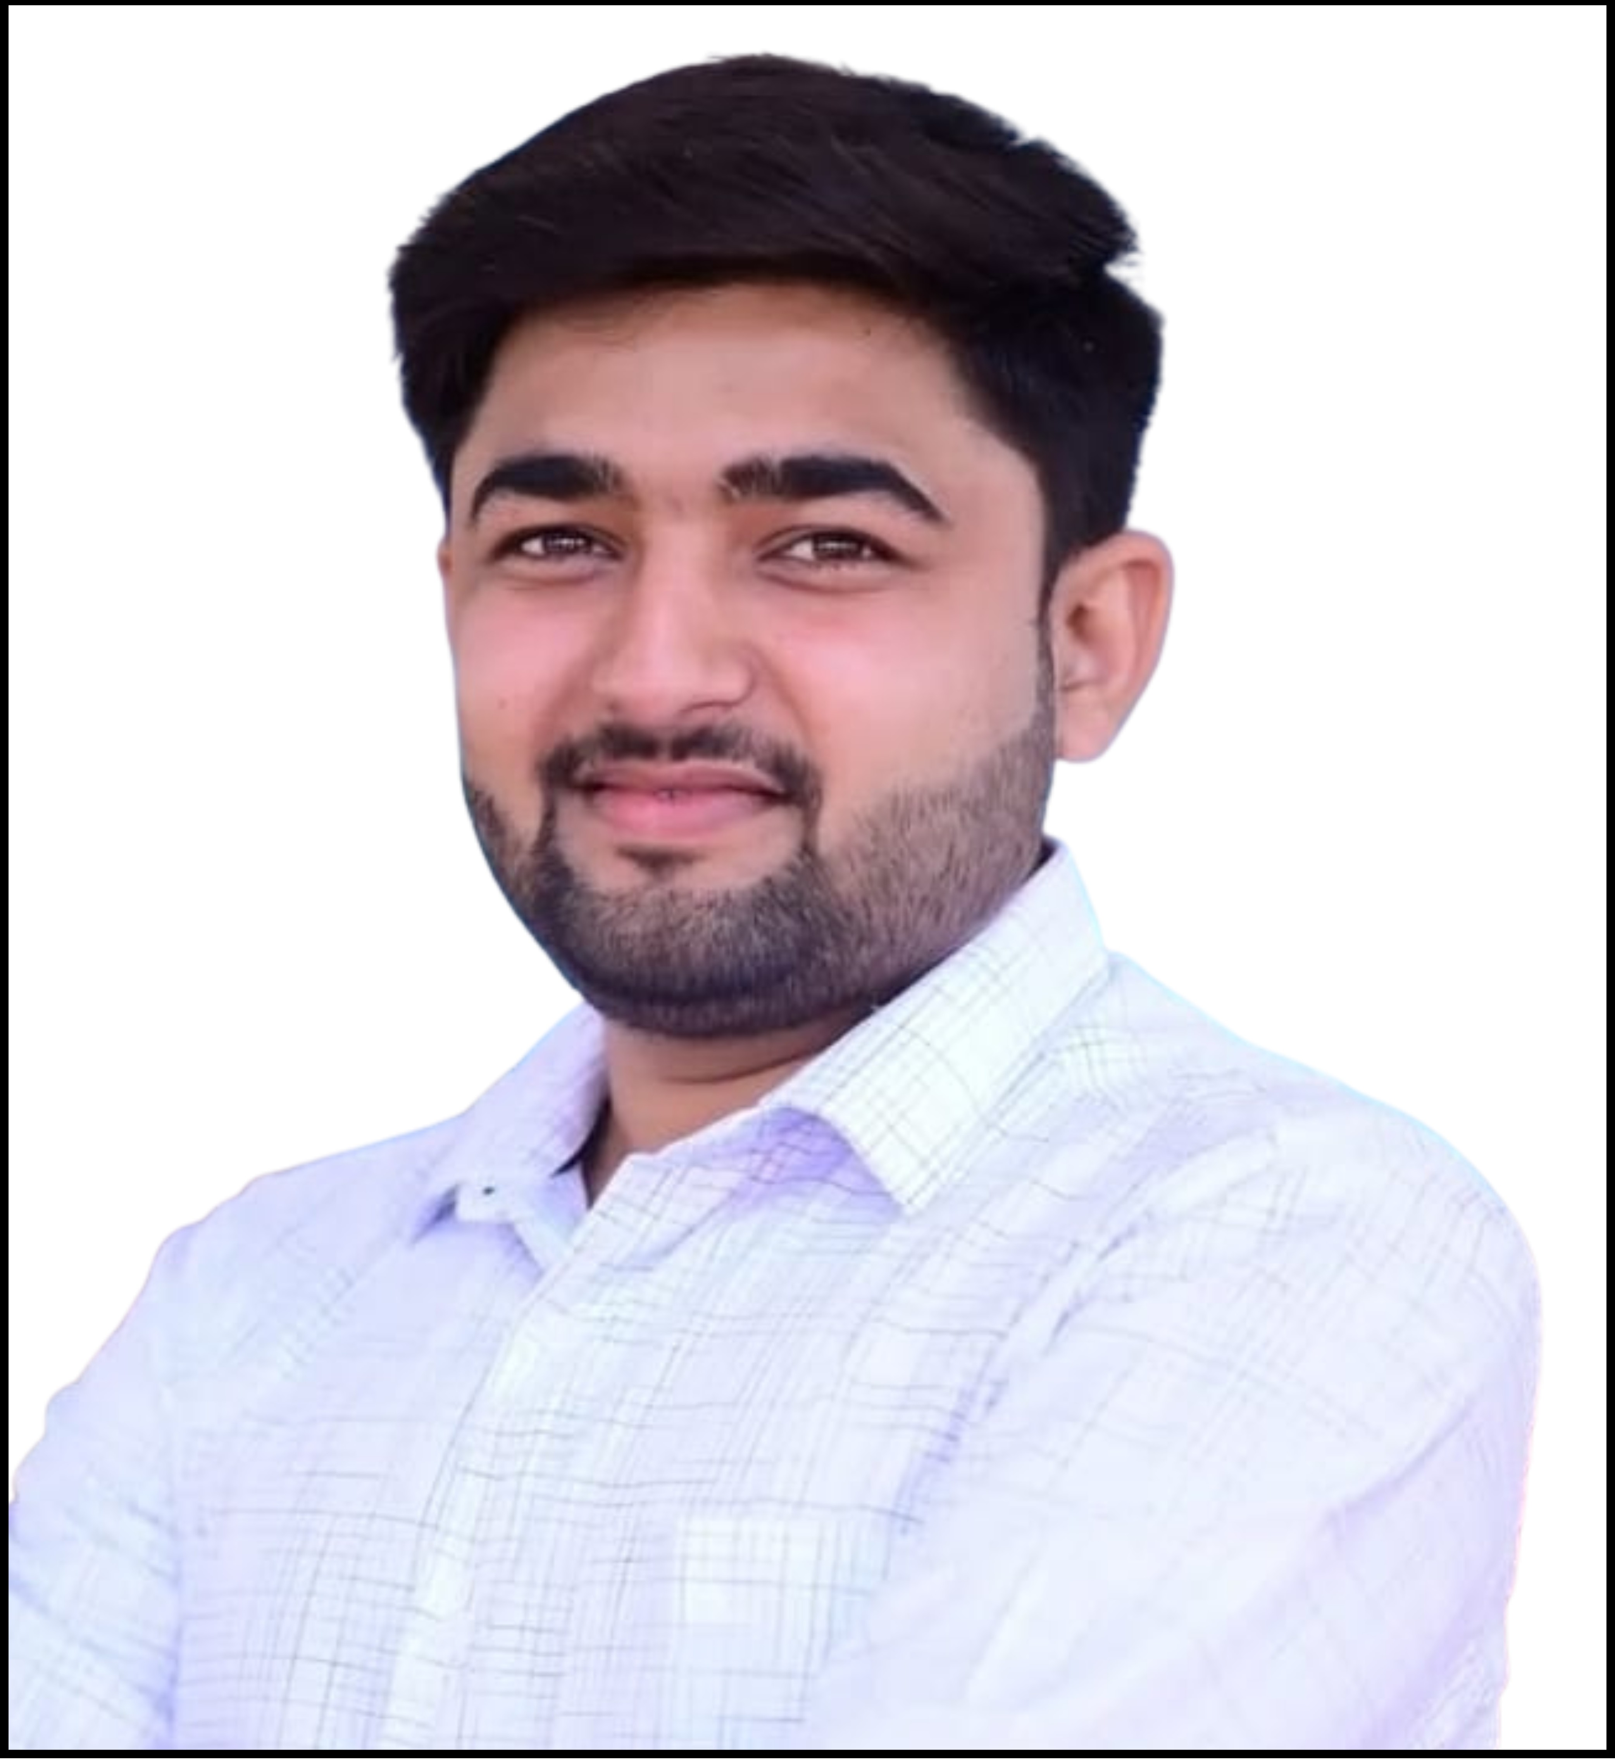

Faculty Profile

Mr. Tejas S. Deshmukh

|  |  |  |
| --- | --- | --- |
| **Qualifications** | **: B. Pharm** | |
| **Specialization** | **: -** | |
| **Department** | **: Pharmacy** | |
| **Designation** | **: Lecturer** | |
| **Experience** | **Industry: 3 Y** | **Teaching: 5 Months** |
| **Publication** | **: 0** | |
| **Award/Recognition** | **: -** | |
| **Membership** | **: MSPC** | |
| **Email** | **: tejasdeshmukh45@gmail.com** | |